- Create a table listing 3 types of printers, 2 types of scanners, and 2 types of webcams, and for each, write one real-life use case (for example: 'Inkjet printer – printing college assignments').
Answer:
Device Type | Type | Real-Life Use Case
Printer | Inkjet Printer | Printing college assignments and color photos.
Printer | Inkjet Printer | Printing office documents in large quantities.
Printer | 3D Printer | Creating prototypes and 3D models.
Scanner | Flatbed Scanner | Scanning certificates, photos, and documents.
Scanner | Handheld Scanner | Scanning pages from books or documents while traveling.
Webcam | Built-in Webcam | Attending online classes on a laptop.
Webcam | External USB Webcam | Making video calls and attending online meetings on a desktop computer.

- Draw a labeled diagram showing how a typical home printer connects to a laptop or PC, including the connection interface used (USB, Wi-Fi, or Bluetooth).
Answer:
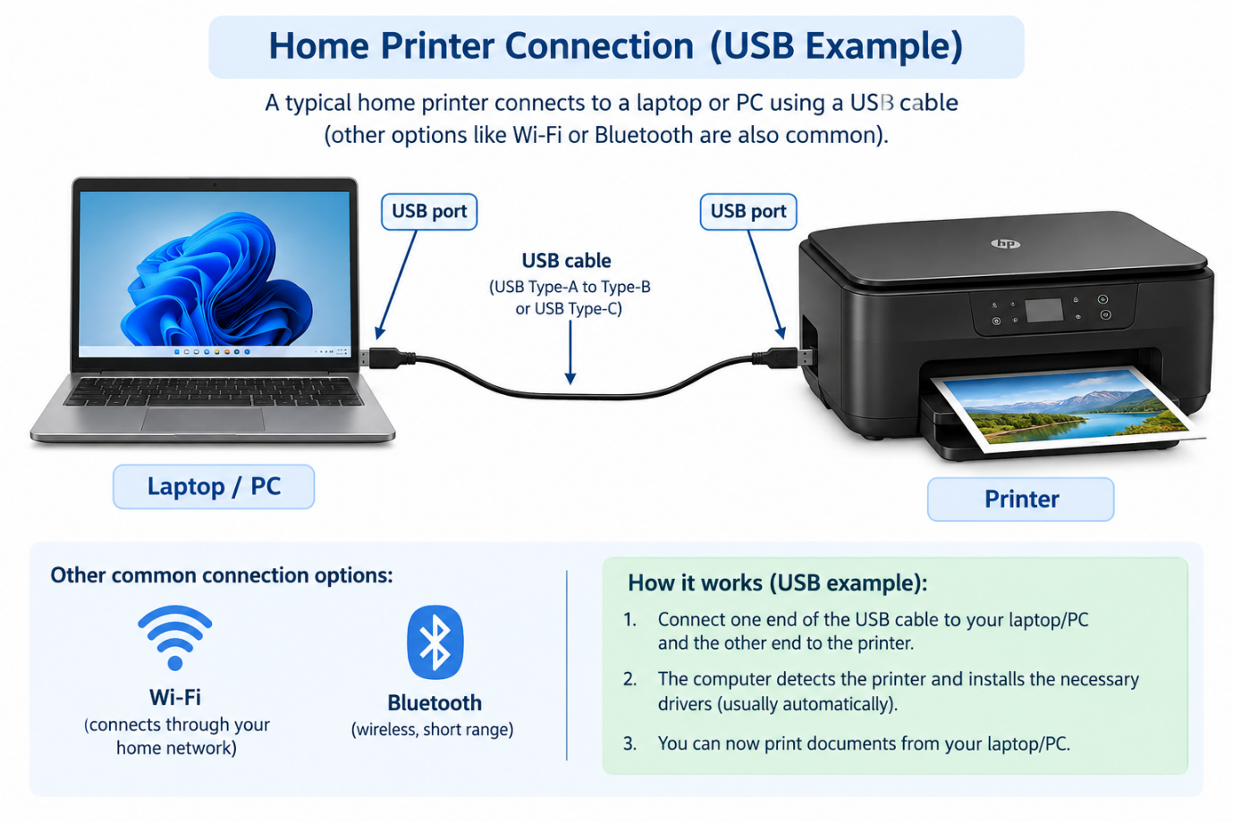
- List three different connection interfaces (such as USB, Wi-Fi, Bluetooth) used by peripherals like printers, scanners, and webcams, and for each, name one advantage and one disadvantage. Think about speed, convenience, and compatibility.
Answer:
Connection Interface | Advantage | Disadvantage
USB | Fast and reliable connection with low delay. | Requires a physical cable.
Wi-Fi | Connects wirelessly and allows multiple devices to share a printer. | May be affected by weak network signals.
Bluetooth | Wireless connection that is convenient for nearby devices. | Usually has a shorter range and lower speed than Wi-Fi.

- Pick any one device you use at home or college (printer, scanner, or webcam). Write step-by-step instructions for how you would connect it to your computer, including what cable or wireless method you would use and any setup steps required.
Answer:

Steps to connect the printer
1. Place the printer: Keep the printer near the computer and connect it to a power supply.
2. Turn on the printer: Press the power button and make sure the printer is ready.
3. Connect the USB cable: Plug one end of the USB cable into the printer and the other end into an available USB port on the computer.
4. Install the printer driver: Windows 11 may automatically detect the printer and install the required driver. If it does not, download the correct driver from the printer manufacturer's official website.
5. Check the connection: Open Settings → Bluetooth & devices → Printers & scanners and check whether your printer appears in the list.
6. Print a test page: Select your printer, open its printer properties or management options, and choose Print test page if available.

